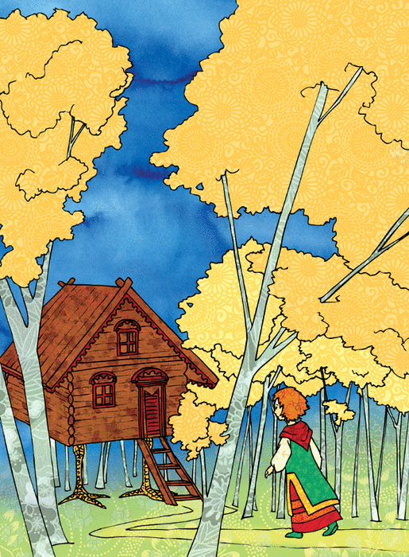

In a village in the Russian countryside lived a little girl who had no mother. Her father remarried, but he chose a bad woman. She hated the little girl and treated her badly. "How can I get rid of this child?" thought the stepmother. One day when her husband went to the market to sell wheat, she said to the little girl, "Go to my sister, your kind aunt, and ask her for a needle and thread to sew you a shirt.

The little girl put on her pretty red kerchief and left. On the way, she said to herself, how clever she was, "I'll go first to ask my real nice aunt, my real mommy's sister." Her aunt received her kindly.

"Aunt," said the little girl, "Daddy's new wife sent me to her sister's house to ask for a needle and thread to sew me a shirt. But first, I came to ask you for some good advice.

- You were right. Your stepmother's sister is none other than Baba Yaga, the cruel ogress! But listen to me: there is a birch tree in her garden that will want to whip your eyes with its branches, tie a ribbon around its trunk. You'll see a big gate that creaks and wants to close itself, put oil on its hinges. Dogs will want to eat you, throw them some bread. Finally, you'll see a cat that would poke your eyes out, give it a piece of ham.

- Thank you very much, Auntie," said the little girl.

She walked for a long time and finally arrived at Baba Yaga's house. Baba Yaga was weaving. "Hello, aunt.

- Hello, my niece.

- My mother sent me to ask you for a needle and thread to sew me a shirt.

- Well, I'll go and get you a straight needle and white thread. In the meantime, sit down in my place and weave.

The little girl began to weave. She was very happy.

Suddenly she heard Baba Yaga say to her servant in the courtyard: "Heat the bath and wash my niece thoroughly. I want to eat her for dinner."

The little girl trembled with fear. She saw the maid enter and bring logs, bundles and buckets full of water. Then she tried to put on a friendly, cheerful voice, and said to the maid, "Hey, maid, split less wood, and to bring the water, use a colander instead!" And she gave her her pretty red kerchief.

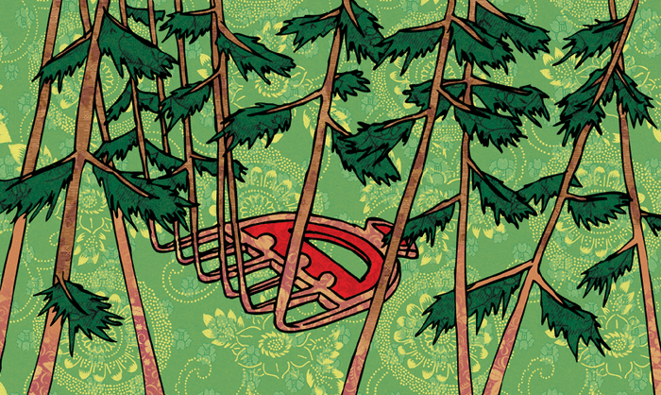

The little girl looked around. A bright fire began to blaze in the fireplace, the water began to sing in the cauldron, and although it was ogre water, it sang a pretty song.

But Baba-Yaga was getting impatient. From the courtyard she asked: "Are you weaving, my niece? Are you weaving, my dear?

- I am weaving, aunt, I am weaving."

Without making a sound, the little girl got up, went to the door... But the cat was there, skinny, black, scary! With his green eyes he looked at the blue eyes of the little girl. And already he was taking out his claws to gouge them. But she gave him a piece of ham and asked him gently: "Tell me, please, how can I escape from Baba-Yaga?"

The cat first ate the whole piece of ham, then smoothed his whiskers and answered, "Take this comb and towel, and run away. Baba-Yaga will come after you. Stick your ear to the ground, if you hear her approaching, throw the towel away, and you'll see! If she is still chasing you, stick your ear to the ground again, and when you hear her on the road, throw the comb, and you will see!"

The little girl thanked the cat, took the towel and the comb, and ran away.

But as soon as she left the house, she saw two dogs even skinnier than the cat, ready to devour her. She threw some soft bread at them, and they did not harm her.

Then the big fence creaked and tried to close to prevent her from leaving the pen. But as her aunt had told her, she poured a whole can of oil on the hinges, and the gate opened wide to let her through. On the way, the birch tree whistled and waved to whip her eyes. But she tied a red ribbon to its trunk, and the birch greeted her and showed her the way.

She ran, she ran, she ran. In the meantime, the cat started to weave. From the courtyard, Baba-Yaga asked again: "Are you weaving, my niece? Are you weaving, my dear?

- I am weaving, old aunt, I am weaving," replied the cat in a big voice."

Furious, Baba-Yaga rushed into the house. No more little girl! She scolded the cat and shouted: "Why didn't you gouge her eyes out, traitor?

- Hey!" said the cat. I have been in your service for a long time, and you never gave me the smallest bone, while she gave me ham!"

Baba-Yaga scolded the dogs. Hey!" said the dogs. We have been in your service for a long time, and have you only thrown us an old crust? While she gave us soft bread!"

Baba-Yaga shook the fence. Hey!" said the fence. I have been in your service for a long time, and you have never put a single drop of oil on my hinges, while she has poured a whole can of it on me!"

Baba-Yaga attacked the birch tree. Hey!" said the birch. I have been in your service for a long time, and you have never decorated me with a thread, while she has adorned me with a beautiful silk ribbon!

- And I," said the maid, who was not asked to do anything, "and I, in all the time I have been in your service, have never received from you even a rag, while she has given me a pretty red kerchief!

Baba-Yaga whistled her mortar, which arrived belly down, and she jumped in. Playing with the pestle and erasing her tracks with her broom, she ran after the little girl, through the countryside.

The little girl stuck her ear to the ground and heard Baba Yaga approaching. Then she threw the towel which turned into a large river! Baba-Yaga was forced to stop.

She gritted her teeth, rolled her yellow eyes, ran to her house, brought her three oxen out of the stable and brought them to the river. And the oxen drank all the water to the last drop. Then Baba-Yaga resumed her pursuit.

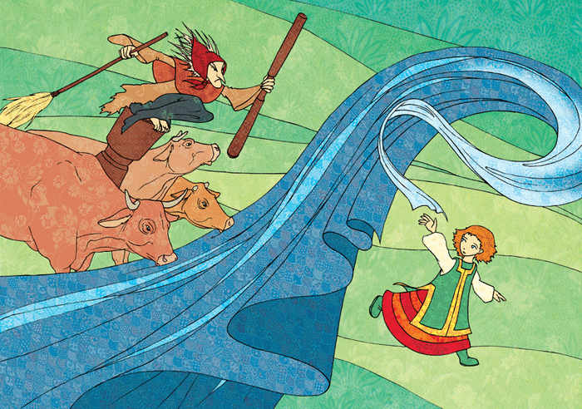

The little girl was far away. She stuck her ear to the ground. She heard the pestle on the road. She threw the comb and it turned into a thick forest! Baba-Yaga tried to enter it, to saw the trees with her teeth. But she couldn't! The little girl listened: nothing more. She only heard the wind blowing between the green and black trees of the forest.

Baba-Yaga - illustration 3

Yet she kept running very fast because it was getting dark, and she thought, "My daddy must think I'm lost."

The old peasant, returning from the market, had asked his wife: "Where is the little one?

- Who knows!" replied the stepmother. I sent her to her aunt's house to run an errand hours ago. Finally, the little girl, her cheeks all red from running, arrived at her father's house. He asked her:

"Where are you from, my little one?

- Ah!" she said. Little father, my mother sent me to my aunt's house to get a needle and thread to sew me a shirt, but my aunt is Baba Yaga, the cruel ogress!

And she told her whole story. The old man was very angry. He beat the stepmother and chased her out of his house, ordering her never to return.

Since then, the little girl and her father have lived in peace. I went to their village, they invited me to their table, the meal was very good and everyone was happy.

Collectif, Contes d'Europe, ill. Isabelle Anglade, rue des enfants